|  |  |  |  |
| --- | --- | --- | --- |
| Course: | HD in Artificial Intelligence and Robotics |  | Official Use |
| Course code: | EG114728 |  |
| Module: | Industrial Automation |  |
| Module code: | MBS4521 |  |

**Lab 5:**

**Programmable Logic Controller II – Controlling Pneumatic circuits**

|  |  |  |  |
| --- | --- | --- | --- |
| Student Name: | Cheung Tsz Chun Noddy |  | **Notes to Students**:   1. Maximum of 4 members per group for software/hardware development 2. Submit this lab sheet in pen writing 3. **Individual submission required** 4. Use spaces given for each part 5. Due date will be given in lab session 6. A maximum of 5% will be deducted for untidiness 7. Late submission will normally not be accepted |
| Student number: | 220171174 |  |
| Names of other members: | 1.  2.  3. |  |
| Date received:  Due date: | 1/4 |  |
| Signature: | Noddy |  |

**Objective**

After completion of this lab, students should be able to:

1. design sequential control pneumatic circuit ladder with a PLC software.

2. build and debug PLC pneumatic circuits and test with PLC ladder.

**Introduction**

With previous experience in PLC ladder design with simple I/O circuits, students should be able to control more real-world systems with different type of sensors and actuators. In this session, students will be experiencing how to migrate the hard-wiring electro-pneumatic circuit control to PLC control of the same circuit operation. Also, students will be control DC motors with direction control.

**Solenoid**

Internal structure

* 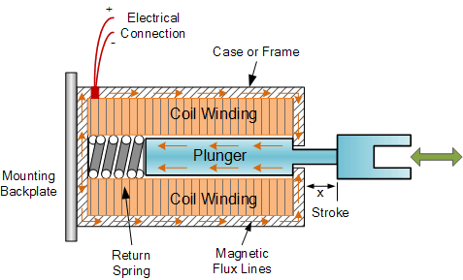Two basic configuration: “**Pull-type**” as it pulls the connected load towards itself when energized, and the “**Push-type**” that act in the opposite direction pushing it away from itself when energized.

**Fig. 1 Internal Structure of a Solenoid**

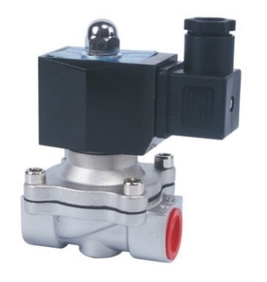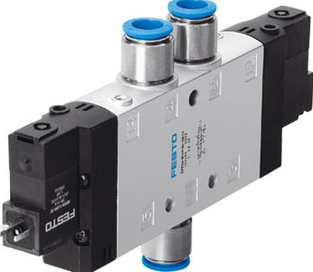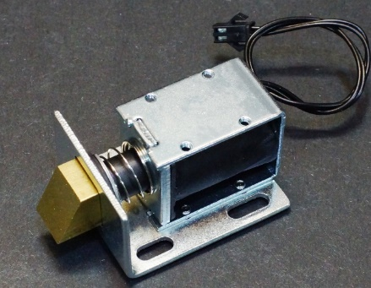Solenoids applications

**Solenoid door lock**

**Solenoid Valve**

**Double Solenoid Pneumatic Control Valve**

**Fig. 2 Components built with Solenoids**

**Timer-delay relay**

Fig.3 shows an example of a timer relay. Time-delay relay contacts must be specified not only as either normally-open or normally-closed, but whether the delay operates in the direction of closing or in the direction of opening.

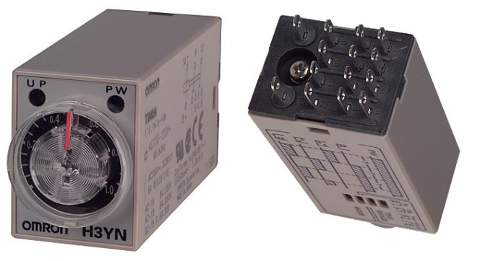

**Fig.3 A timer relay**

A special class of electromechanical relays called time-delay relays provide delayed action, either upon power-up or power-down, and are commonly denoted in ladder logic diagrams by "TD", "TR" or “T” designations near the coil symbols and arrows on the contact symbols.

Fig.4 shows an example of a time-delay relay contact used in a solenoid control circuit:

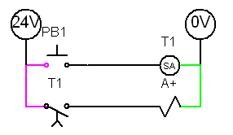

3 sec.

In this circuit, the solenoid, A+, delays start-up until three seconds after the pushbutton, PB1, is pressed, but will stop immediately when the pushbutton is released. The relay contact is referred to as normally-open, timed-closed, or NOTC. It is alternatively referred to as a normally-open, on-delay contact.

Below are both written and visual descriptions on how some of the common timing functions operate. A Timing Chart shows the relationship between Input Voltage, Trigger (if present) and Output.

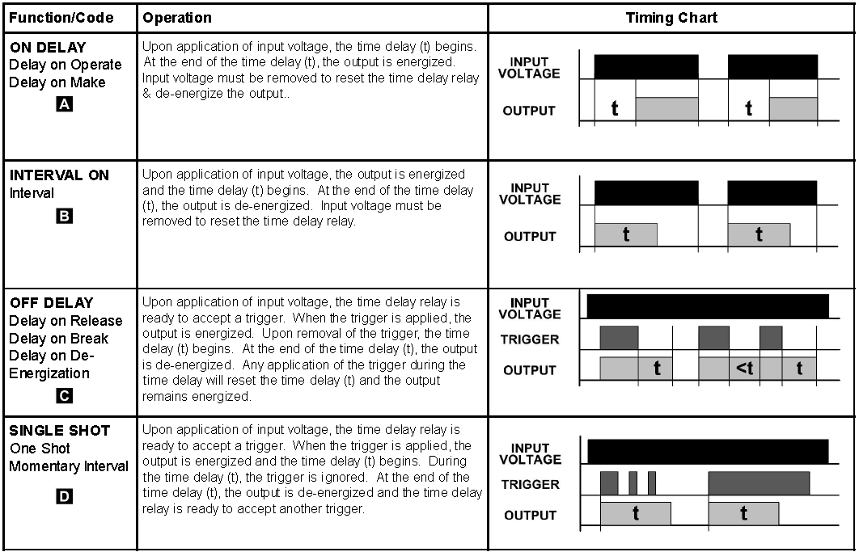

**Fig.5 ON DELAY and OFF DELAY explained with timing chart**

In this laboratory session, students are required to work in groups (4 members maximum). Each group is required to write and design PLC ladder diagrams and connect I/O devices to test the functionality of programs. Every student should hand in his/her own lab sheet one week after the lab session.

**Apparatus**

1. Programmable Logic Controller software (Panasonic NAIS FP Win GR ver. 2.0)

2. PLC – FP Sigma (Model: FPG-C32T2H)

3. Personal computers

4. I/O Hub, Button-Light Box, cable and accessories

5. Electro-pneumatic components, Pneumatic training board

6. Sensors and motors.

**Procedures**

**Part A – A double acting cylinder performing an oscillatory movement with delay operation run in PLC (20%)**

A double acting cylinder is controlled by a 5/2 double solenoid actuated directional control valve with two limit switches as position sensors. A timer relay is used to delay the cylinder after it reaches its maximum extended position.

**Actuation requirement:** *When a START button (NO) is pressed (one shot with spring return), the cylinder will extend to its limit position, stay still for 5 seconds, and then it will return to its fully retracted position. The cycle repeats again automatically. When the STOP button is pressed, the cylinder will stop running after that cycle.*

The electro-pneumatic sub-circuit and the ladder diagram are given below:

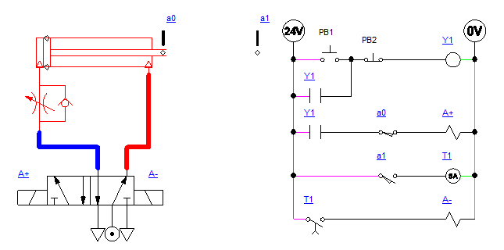

|  |  |  |  |  |  |  |  |  |  |  |  |  |  |  |  |  |  |  |
| --- | --- | --- | --- | --- | --- | --- | --- | --- | --- | --- | --- | --- | --- | --- | --- | --- | --- | --- |
| **A1.** Draw the I/O assignment table for PLC connection.   |  |  |  | | --- | --- | --- | | **Connected to** | **Input address** | **Output address** | | Pushbutton PB1 (NO) | X0 |  | | Sensor a0 (NO) | X1 |  | | Sensor a1 (NO) | X2 |  | | Solenoid A+ |  | Y6 | | Solenoid A- |  | Y7 |   Pushbutton PB2 (NO) X3 |

|  |
| --- |
| **A2.** Sketch the PLC wiring circuit. |

|  |
| --- |
| **A3.** Redraw the electromechanical ladder into a PLC ladder. |

**A4. Use the pneumatic training board and the given PLC to operate the circuit.**

Official use:

Satisfactory / Minor assistance required / Major assistance required / Incomplete

**Part B – Controlling multiple cylinders (50%)**

**Given:**

* **Two double acting cylinders,**
* **Two 5/2 double solenoid directional control valves,**
* **Four limit switches,**
* **one momentary pushbutton.**

**Connect all components to PLC and design a PLC ladder to control the motion sequence as given.**

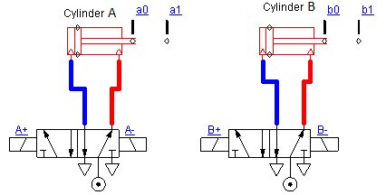

**B1. Control the below sequence with the pushbutton being pressed momentarily. Use a single cycle design, i.e. the sequence will only be run once when the pushbutton is pressed momentarily.**

**A+, 3 seconds, B+, 3 seconds, B-, 3 seconds, A-**

**Sequence:**

|  |  |  |  |  |  |  |  |  |  |  |  |  |  |  |  |  |  |  |  |  |  |  |  |  |  |  |  |  |  |  |
| --- | --- | --- | --- | --- | --- | --- | --- | --- | --- | --- | --- | --- | --- | --- | --- | --- | --- | --- | --- | --- | --- | --- | --- | --- | --- | --- | --- | --- | --- | --- |
| **B1.1** Complete the below I/O Assignment Table:   |  |  |  | | --- | --- | --- | | **Connected to** | **Input address** | **Output address** | | Pushbutton PB1 (NO) | X1 |  | | Sensor a0 (NO) | X2 |  | | Sensor a1 (NO) | X3 |  | | Sensor b0 (NO) | X4 |  | | Sensor b1 (NO) | X5 |  | | Solenoid A+ |  | Y3 | | Solenoid A- |  | Y2 | | Solenoid B+ |  | Y5 | | Solenoid B- |  | Y4 | |

|  |
| --- |
| **B1.2** Draw a circuit to connect the double acting cylinders to two 5/2 double solenoid valves and the PLC with four limit switches and a pushbutton. |

**B1.3 Use the pneumatic training board and the given PLC to operate the circuit.**

Official use:

Satisfactory / Minor assistance required / Major assistance required / Incomplete

**B2. With the circuit built in B1/B2, implement the following motion sequence in single cycle mode**.



**Sequence:**

**Start, A+, delay 5 seconds, B+, B-, B+, B-, delay 3 seconds, A-**

|  |
| --- |
| **B2.1** Design a PLC ladder to achieve the required sequence. |

**B2.2 Use the pneumatic training board and the given PLC to operate the circuit.**

Official use:

Satisfactory / Minor assistance required / Major assistance required / Incomplete

